

CUSTOMER CARE REGISTRY

**PROJECT PLANNING**

**TEAM DETAILS:**



**Team No :** PNT2022TMID50320

**College Name :** P.S.R.Rengasamy College of Engineering

**Department :** Computer Science & Engineering

|  |  |
| --- | --- |
| Date | 18October 2022 |
| Team ID | PNT2022TMID50320 |
| Project Name | Customer Care Registry |
| Maximum Marks | 8 Marks |

**PROJECT PLANNING**

# Product Backlog, Sprint Schedule, and Estimation (4 Marks)

## Use the below template to create product backlog and sprint schedule

|  |  |  |  |  |  |  |
| --- | --- | --- | --- | --- | --- | --- |
| Sprint | Functional  Requirement (Epic) | User Story  Number | User Story / Task | Story Points | Priority | Team Members |
| Sprint-1 | User Panel | USN-1 | The user will login into the website and gothrough the  services available on the webpage | 20 | High | SABARISHINI M  KOKILA M |
| Sprint-2 | Admin panel | USN-2 | The role of the admin is to check out the database about the availability and have a trackof all the things that the users are going to service | 20 | High | MUTHU PRIYA V  KAVIYA PRIYA M |
| Sprint-3 | Chat Bot | USN-3 | The user can directly talk to Chatbot regarding the services. Get the recommendations based on information provided by the user. | 20 | High | SABARISHINI M  KOKILA M |
| Sprint-4 | final delivery | USN-4 | Container of applications using docker kubernetes and deployment the application.Create the documentation and final submit the application | 20 | High | MUTHU PRIYA V  KAVIYA PRIYA M |

**PROJECT PLANNING**

# Project Tracker, Velocity & Burndown Chart: (4 Marks)

|  |  |  |  |  |  |  |
| --- | --- | --- | --- | --- | --- | --- |
| Sprint | Total Story Points | Duration | Sprint Start Date | Sprint End Date (Planned) | Story Points Completed (as on Planned End Date) | Sprint Release Date (Actual) |
| Sprint-1 | 20 | 6 Days | 24 Oct 2022 | 29 Oct 2022 |  | 29 Oct 2022 |
| Sprint-2 | 20 | 6 Days | 31 Oct 2022 | 05 Nov 2022 |  | 05 Nov 2022 |
| Sprint-3 | 20 | 6 Days | 07 Nov 2022 | 12 Nov 2022 |  | 12 Nov 2022 |
| Sprint-4 | 20 | 6 Days | 14 Nov 2022 | 19 Nov 2022 |  | 19 Nov 2022 |

**Velocity:**

Imagine we have a 10-day sprint duration, and the velocity of the team is 20 (points per sprint). Let’s calculate the team’s average velocity (AV) per iteration unit (story points per day)

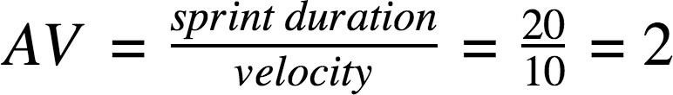

PROJECT PLANNING

BURNDOWN CHART

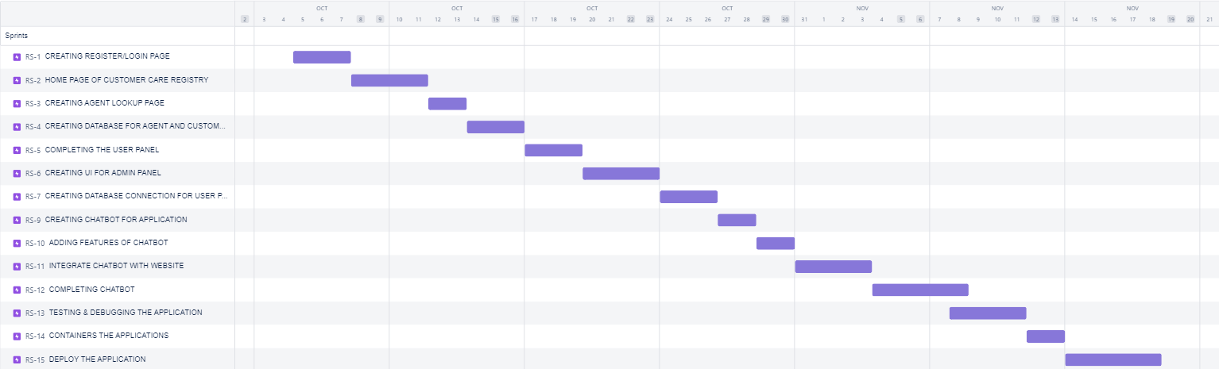



**Thank you**